***Software Requirements Specification***

***for***

Hotel Kiosk

Version 1.0 approved

Prepared by Griffin, Moriah, and Jim

EZ Stay Hotel

October 26, 2018

***Table of Contents***

**Table of Contents................................................................................................................ ii**

**Revision History.................................................................................................................. ii**

**1. Introduction.................................................................................................................... 1**

1.1 Purpose .......................................................................................................................... 1

1.2 Document Conventions ................................................................................................. 1

1.3 Intended Audience and Reading Suggestions ............................................................... 1

1.4 Product Scope................................................................................................................ 1

1.5 References ..................................................................................................................... 1

**2. Overall Description ....................................................................................................... 2**

2.1 Product Perspective ....................................................................................................... 2

2.2 Product Functions........................................................................................................... 2

2.3 User Classes and Characteristics ................................................................................... 2

2.4 Operating Environment ................................................................................................. 2

2.5 User Documentation....................................................................................................... 2

2.6 Assumptions and Dependencies .................................................................................... 3

**3. External Interface Requirements ................................................................................. 3**

3.1 User Interfaces ............................................................................................................. 3

3.2 Software Interfaces ........................................................................................................ 3

3.3 Communications Interfaces ........................................................................................... 3

**4. System Features.............................................................................................................. 4**

4.1 System Feature 1 ........................................................................................................... 4

4.2 System Feature 2 (and so on) ........................................................................................ 4

**5. Other Nonfunctional Requirements ............................................................................ 4**

5.1 Performance Requirements ........................................................................................... 4

5.2 Safety Requirements...................................................................................................... 5

5.3 Security Requirements .................................................................................................. 5

5.4 Software Quality Attributes .......................................................................................... 5

5.5 Business Rules .............................................................................................................. 5

**6. Other Requirements ...................................................................................................... 5**

**Appendix A: Glossary........................................................................................................ 5**

**Appendix B: Analysis Models .......................................................................................... 5**

**Appendix C: To Be Determined List................................................................................ 6**

**Revision History**

|  |  |  |  |
| --- | --- | --- | --- |
| **Name** | **Date** | **Reason for Change** | **Version** |
|  |  |  |  |
|  |  |  |  |

**1. Introduction**

**1.1 Purpose**

The purpose of this SRS document is to provide a detailed description of the EZ Stay Hotel Kiosk System. It will explain the system features, the systems interfaces, and how the system will function. It will also cover how the system will interact to external stimuli. This document is intended for the stakeholders and the developers of the system.

**1.2 Document Conventions**

This document is split into section which are each further split into sub-section. Each section is explained in detail with the use of these sub-sections. Each requirement has a priority which is stated in the requirement itself.

**1.3 Intended Audience and Reading Suggestions**

This document was created for developers and hotel employees. This document should be read sequentially by all those reading it. Section 3 and 4 are most important for developers. Section 2 is the most useful section for hotel employees.

**1.4 Product Scope**

The Hotel Kiosk software system was developed to make the hotel experience as seamless as possible by removing the chance for human error. Many people may be able to relate to a hotel circumstance where the front desk processes take upwards of thirty minutes due to lackadaisical clerks. The benefit of the clerkless hotel kiosk is that it can complete the same job in a speedy manor. The goal of the software is to change the way hotel services are run and to consequently make staying at a hotel a more popular option.

**2. Overall Description**

**2.1 Product Perspective**

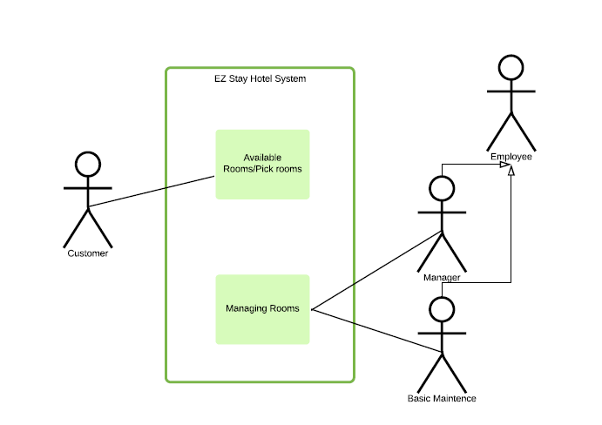

**Figure 1. System Environment simple version**

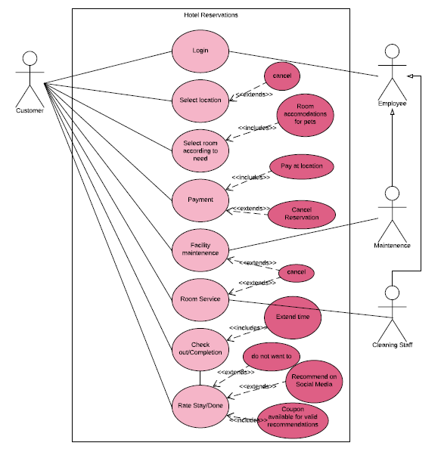

**Figure 2: Detailed use Case Diagram**

The EZ Stay Hotel System has three active actors and one cohesive system. The Customer and employees have access to the system through a touch-screen kiosk. The system can be used as a communication device between customer and employee when a request is needed to be completed. The closest employee will be notified of a specific request, to avoid a buildup of a vast amounts of requests, resulting in a backup. The software will be used to replace the functionality of a front desk. The system will be a semi-self-contained product. The SRS defines a component of a larger system that allows a potential customer to sign up/login and pay for a room, employees to make changes to their schedule, and view their schedule. All of which will be stored on a database, where each name and the entire system can be accessed only by an administrative authority.

**2.2 Product Functions**

This section outlines the use cases for the active customer.

2.2.1 Customer Use Case

**Diagram:** Refer to Figure 2.

**Brief Description:**

The Customer will be able to view all of the available rooms and pick a room according to their needs, such as accommodations for pets as well has how many people will be staying in the designated room.

**Initial Step-By-Step Description**

* Login, with valid credentials
* The system will save information about the user
* Allows the customer to purchase a room
* Allows the customer to purchase a food plan
* Gives back a receipt for the customer

2.2.2 Employee Use Case [Administrative]

**Diagram:** Refer to Figure 2.

**Brief Description:**

An administrative employee will be able to see all information on every person and will be able to approve any changes to the employee schedule as well as see their own in schedule.

**Initial Step-By-Step Description**

* Login, with valid credentials
* Has authorization to see any information in the database
* Allows employee to ask for time off
* Allows employees to put in a 2 weeks’ notice

2.2.3 Employee Use Case [basic maintenance]

**Diagram:** Refer to Figure 2.

**Brief Description:**

A simplistic version of the administrative employee. The employee will be able to view their schedule and edit it with the consent of an administrative employee

**Initial Step-By-Step Description**

* Login, with valid credentials
* Allows employee to view schedule
* Allows employee to ask for time off
* Allows employees to put in a 2 weeks’ notice

**2.3 User Classes and Characteristics**

The Customer, as well as the administrative and basic maintenance employees, are expected to be able to use a tablet/touch screen oriented interface.

The detailed look of these pages is discussed in section 3.2 below.

**2.4 Operating Environment**

The system will operate as a touch-screen kiosk with a high speed interchangeable graphic interface to switch between apps for different users. The speed of the customer’s connection will determine which room they can purchase for a given time. If they take too long, the system will notify the customer that the use has been inactive for too long and in risk of losing their designated room.

**2.5 User Documentation**

User manuals will be supplied with the delivery of the software. On sight, the software will have an option to call an employee to help them with the software.

**2.6 Assumptions and Dependencies**

If the customer has already stayed at a different location with the company, they will not have to make another account, they will only need to use the one they previously made.

**3. External Interface Requirements**

**3.1 User Interfaces**

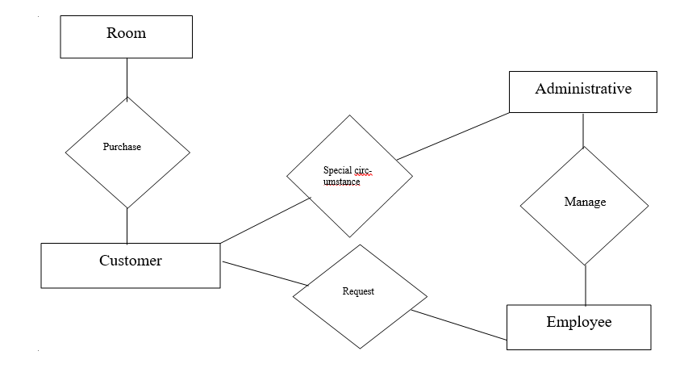

**Figure 3. Logical structure of EZ Stay Hotel**

* Each customer will have the opportunity to purchase a room, which includes checking for valid credentials as well as payment method.
* Each customer can give any number of requests that would be relayed to the nearest located employee
* An administrative employee will be able to manage the schedule of the entire employee payroll

Since this is a touch-screen kiosk there won’t necessarily be keyboard shortcuts, error messages will not appear unless the server containing the room information is offline.

3.1.1 Login

|  |  |
| --- | --- |
| **Use Case Name** | Login |
| **Trigger** | The customer, employee or administrative employee will initiate login |
| **Precondition** | Customer must have valid credentials |
| **Basic Path** | 1. The Customer enters name, SSN#, valid birthday, and valid billing address 2. If customer has already used the system, the system will check if everything is up to date 3. Once logged into account, the customer can view the locations available |
| **Alternative paths** | The Customer can quit at anytime, will time out within 30 seconds if inactive |

3.1.2 Select Location

|  |  |
| --- | --- |
| **Use Case Name** | Select Location |
| **Trigger** | Customer has already logged in and can view different locations |
| **Precondition** | The customer must have already logged in |
| **Basic Path** | 1. Customer has logged in 2. Customer can choose a location 3. Customer can choose to pay at sight or immediately after transaction is processed |
| **Alternative paths** | Customer can quit at any time |

3.1.3 Select Room

|  |  |
| --- | --- |
| **Use Case Name** | Select room |
| **Trigger** | Customer has already picked a location, looking to choose a room at given location |
| **Precondition** | Customer must have logged in, and picked a location |
| **Basic Path** | 1. Customer has already chosen a location 2. Then can see what type of rooms are available for individual need 3. Must click on confirm to ‘save’ room |
| **Alternative paths** | Customer can quit at anytime, can choose rooms with pet accommodations |

3.1.4 Payment

|  |  |
| --- | --- |
| **Use Case Name** | Payment |
| **Trigger** | Customer has reached the end of selecting location and room |
| **Precondition** | Customer must have valid credentials |
| **Basic Path** | 1. Can choose method of payment 2. Must have valid billing address 3. Must click complete 4. The system will process |
| **Alternative paths** | Customer can quit |

3.1.5 Facility Maintenance

|  |  |
| --- | --- |
| **Use Case Name** | Facility Maintenance |
| **Trigger** | Customer wants service concerning facilities; such as plumbing, shower, or sink issues |
| **Precondition** | Customer must enter room number and use ID number |
| **Basic Path** | 1. Customer clicks maintenance button for any issues with plumbing, shower, or sink issues 2. Message will be sent to nearest employee to room number 3. Employee will come as soon as possible |
| **Alternative paths** | Customer can cancel for any reason |

3.1.6 Room Service

|  |  |
| --- | --- |
| **Use Case Name** | Room Service |
| **Trigger** | Customer wants service concerning room service such as bedding, or complimentary |
| **Precondition** | Customer must enter room number and use ID number |
| **Basic Path** | 1. Customer selects Room service 2. Message is sent to the nearest employee to room number 3. Employee will come as soon as possible |
| **Alternative paths** | Customer can cancel at anytime |

3.1.7 Check Out/ Complete

|  |  |
| --- | --- |
| **Use Case Name** | Check Out/Complete |
| **Trigger** | Customer has reached the end of his time |
| **Precondition** | Customer must have had a room prior to checking out |
| **Basic Path** | 1. Customer will press check out button 2. Confirm their room number and confirm checking out 3. ID card become invalid 4. Must check out at proper time or account will be charged for a late fee 5. Allows room service to fix the room |
| **Alternative paths** | The Customer has the option to extend stay |

3.1.8 Rate Stay/ Done

|  |  |
| --- | --- |
| **Use Case Name** | Rate Stay/Done |
| **Trigger** | Customer has checked out |
| **Precondition** | Customer must have checked out and paid |
| **Basic Path** | 1. Once check out is complete, the customer will given the option to rate their stay according to the service they received 2. Customer will also be given the option to recommend on social media 3. If the customer recommends on social media, makes available a coupon for their next stay |
| **Alternative paths** | Customer does not have to complete, |

**3.2 Software Interfaces**

* Operating System: Window 10
* Coding Language: Java
* Database: MYSQL

The data items or messages coming into the system are the information from the customer to organize the order of which the customers come in. The overall purpose is to make an orderly database. Services needed are fulfilling requests made from customers, fulfilled by employees. The nature of communication will come by a pager, where requests can be made by a customer and it will be fulfilled by the nearest employee to the area in need of service.

**3.3 Communications Interfaces**

This system will use graphic interfaces such as FTP and HTTP.

**4. System Features**

**4.1 Login using card swipe**

**4.1.1 Description and Priority**

User whose credentials already exist in the system will be able to use the card that has been provided to them to login to the system any number of times after it has been issued. Note that new users will have to manually register their credentials into the system for the first time only. Swipe to login will work across all locations without requiring additional registration.

Priority: high

**4.1.2 Stimulus/Response Sequences**

Stimulus: User interacts with idle system.

Response: System reveals login screen.

Stimulus: User registers account by inputting credentials.

Response: System prints user’s swipe card.

Stimulus: User swipes card on kiosk.

Response: System logs user in based on credentials associated with card.

**4.1.3 Functional Requirements**

**REQ-1**: The system shall prevent accounts with identical credentials from being created.

|  |  |
| --- | --- |
| **Purpose** | Users may not be issued multiple swipe cards and thus shall only have a single account. |
| **Implementation** | When registering an account with identical credentials as one already in the system, upon submission the registration will be automatically cancelled. |

**4.2 Check-in**

**4.2.1 Description and Priority**

Once logged in, a user will have the option to check-in. The user will be prompted to choose a date, choose an available room, and lastly pay. Access to the room is linked to the users card.

Priority: high

**4.2.2 Stimulus/Response Sequences**

Stimulus: User chooses available date.

Response: System user shows rooms that are available and unavailable on specified date/date

range.

Stimulus: User chooses clean and available room.

Response: System marks room as taken by user if room is available on specified date/date

range.

Stimulus: User pays for room.

Response: System calculates cost based on room and date range. User is charged through

payment choice specified in credentials.

**4.2.3 Functional Requirements**

**REQ-2**: The system shall display clean and available rooms upon user specified dates.

|  |  |
| --- | --- |
| **Purpose** | When searching for a room, the system will only display rooms that are unoccupied and have since been cleaned by the cleaning staff. This ensures users don't pay for already occupied rooms and/or dirty rooms. |
| **Implementation** | System shall provide a graphical layout of each floor with an easy to read available/unavailable identification on each room. |

**REQ-3**: The system shall calculate cost to stay for the user and charge them on their

approval.

|  |  |
| --- | --- |
| **Purpose** | Allows for an easy cash free method of transaction that relies on previously entered credentials stored with the users data. Will wait on users approval as to not wrongfully charge anyone. |
| **Implementation** | System shall use the users data (credit/debit info) to charge them based on cost of room per night times number of nights. This will only be done with user confirmation; failure to confirm will cancel order and return user to available room display. |

**REQ-4**: The system shall validate user’s data (credit/debit info) upon each attempt of transaction and request a credential update should the info be out of date.

|  |  |
| --- | --- |
| **Purpose** | Ensure that the user is able to pay for the services provided by hotel. |
| **Implementation** | When charging user payment method, if the method is rejected, notify user and prompt them to update their info. |

**4.3 Check-out**

**4.3.1 Description and Priority**

Once the users stay has been expended, their card will no longer function as a key to their room. To check out, the user must return to the kiosk in order to confirm that their room is no longer occupied. The room is then made available in the systems database.

Priority: high

**4.3.2 Stimulus/Response Sequences**

Stimulus: User logs in and selects “Check-out”.

Response: System prompts user to confirm the room is no longer occupied.

Stimulus: User confirms room is no longer occupied.

Response: System marks room now as available.

**4.3.3 Functional Requirements**

**REQ-5**: The system shall deactivate key functionality to users swipe card when time exceeds time range that has been paid for.

|  |  |
| --- | --- |
| **Purpose** | Users may not stay longer than what they have scheduled for. |
| **Implementation** | When registering an account with identical credentials as one already in the system, upon submission the registration will be automatically cancelled. |

**REQ-6**: User shall be able to extend stay at kiosk while their card is still active for the room

they are in.

|  |  |
| --- | --- |
| **Purpose** | Allow user to stay longer if necessary. |
| **Implementation** | Shall be possible by disallowing rooms to be booked until a full day after another user has stayed in said room. This ensures that future users won't pay for a room only to not find another user already there. |

**4.4 View Account**

**4.4.1 Description and Priority**

Users with existing registration can view their information and make changes if necessary. Primarily this function will be used by cleaning staff to clock in, view schedule, or request to switch shifts with another employee.

Priority: medium

**4.4.2 Stimulus/Response Sequences**

Stimulus: Logged in user selects “View account”

Response: System pulls up users account information.

Stimulus: Employee selects “View schedule”

Response: System displays work schedules for the month, including shifts of other employees.

Stimulus: Employee selects “Switch shifts”

Response: System sends notification the employee whose shift is requested to be traded.

**4.4.3 Functional Requirements**

**REQ-7**: The user shall be able to edit credentials.

|  |  |
| --- | --- |
| **Purpose** | If users wish to enter another payment method or their billing address is changed, they may make those changes. |
| **Implementation** | The user shall have the option, after logging in, to view and edit their credentials in a separate interface. |

**REQ-8**: Employees shall be able to view their work schedule.

|  |  |
| --- | --- |
| **Purpose** | Employees will need to know what days they are working. |
| **Implementation** | System will have an interface similar to a calendar displaying shifts for all employees within the current month. Employees may look ahead to future months granted their schedule has already been determined. |

**REQ-9**: Employees shall be able to clock in and out using the system.

|  |  |
| --- | --- |
| **Purpose** | Employees need to log their hours in order to be paid. |
| **Implementation** | Employees should be instructed to swipe their card when they arrive at work. This will act as your time in. Similarly, when an employees shift is over, they will swipe before they leave in order to generate a time out for the system to calculate a total hours worked. |

**REQ-10**: Employees shall be able to request a shift trade with another employee.

|  |  |
| --- | --- |
| **Purpose** | Employees that have an unexpected life event happen to them will be able to get off for that day. |
| **Implementation** | Since every employee must use the system each day to log their hours, the shift trade request will appear on the recipients screen once they log in. They may either accept or deny this. |

**5. Other Nonfunctional Requirements**

**5.1 Performance Requirements**

**NFR-1**: The system should be easy to use.

|  |  |
| --- | --- |
| **Purpose** | The users should find the system easy to operate and simple to understand. |
| **Implementation** | The system should have a concise interface with all necessary requirements apart from functional requirements. |

**NFR-2**: The system should be user friendly.

|  |  |
| --- | --- |
| **Purpose** | The users can easily access the system. |
| **Implementation** | The system should be developed in a friendly way to be simply reached by users. |

**NFR-3**: The system should be fast.

|  |  |
| --- | --- |
| **Purpose** | The users should be able to experience the system with proper and short waiting time. |
| **Implementation** | The interface should process a quick responding time to deal with booking, billing, payments etc. |

**NFR-4**: The systems should be always uptodate.

|  |  |
| --- | --- |
| **Purpose** | The system should update date in database and display as soon as possible. |
| **Implementation** | The system’s work should be efficient and effective by fast updation of all statuses like orders, payments, room availability etc. |

**5.2 Safety Requirements**

**NFR-5**: The system must be backed up often.

|  |  |
| --- | --- |
| **Purpose** | The system needs to be backed up in order to deal with sudden situations. |
| **Implementation** | The system should be backed up every hour in hard drive and web drive. |

**NFR-6**: The system must be maintained weekly.

|  |  |
| --- | --- |
| **Purpose** | The system needs to function as expected with scheduled maintenance. |
| **Implementation** | The managers should run safety check for viruses and attack, and improve or debug if errors or flaws are found weekly. |

**NFR-7**: The system must have emergency response.

|  |  |
| --- | --- |
| **Purpose** | The system should be restored as soon as possible if emergency occurs. |
| **Implementation** | The system should be able to come back at normal operation within an acceptable amount of time. |

**5.3 Security Requirements**

**NFR-6**: The system must protect all users and employees’ personal information.

|  |  |
| --- | --- |
| **Purpose** | To prevent information leakage and dangers or crimes like harassment and fraud. |
| **Implementation** | All external communications between the data’s server and client must be encrypted, and data must be stored and protected. |

**NFR-7**: The system must secure payment transactions.

|  |  |
| --- | --- |
| **Purpose** | To protect the users and employees’ assets |
| **Implementation** | Payment processes must follow secure protocol. |

**5.4 Software Quality Attributes**

* **Usability:** The system should be introduced to every level of users via user manual.
* **Correctness:** The system should operate normal Hotel Management regulations and fulfill user objectives.
* **Efficiency:** The system should achieve the particular task efficiently without any hassle.
* **Flexibility:** The system should be flexible to be edited and add new features.
* **Testability:** The system should be able to be tested to confirm its performance and specifications.
* **Integrity:** The system must secure customer information and avoid data losses.
* **Portability:** The system should be able to run in any Microsoft windows after windows XP. (Android or IOS if possible).
* **Maintainability:** The system should be maintainable.

**5.5 Business Rules**

* There are mainly three types of users using the system, such as user, employee and Administrator.
* Administrator has the full permission of controlling the system.

**6. Other Requirements**

* Undecided at this point

**Appendix B: Analysis Models**